Sample of assignments to enter QualityControl Division

Version 2.1

For

SoftServe IT Academy

December, 2016

Contents
1 OBJECTIVE 3
2 SAMPLE OF ASSIGNMENTS 4
General 4
Understanding of the quality assurance/control process 4
Computer general knowledge 4
Basic programming skills 4
Knowledge of SQL scripts writing 4
3 OTHER ASSIGNMENTS 5
3.1 Databases 5
3.2 Algorithms 6
3.3 QC questions 7
3.4 Logical tasks 7
4 THE MAIN TASK -FAULTS LOCATION TEST 8
5 RECOMMENDED ONLINE-TESTS 9
6 REFERENCES 9

1 OBJECTIVE
This document has been prepared to make the process of entering SoftServe IT Academy, namely its Quality Control Division easier and more understandable for the candidates. Here there are described the requirements to the level of the candidates’ knowledge, there are given the test samples, there is recommended an online-test, a test to determine the level of knowledge and there is given the reference list.

2 SAMPLE OF ASSIGNMENTS

General
Entrance test consists of two parts:

1. The first part tests the candidates’ general knowledge on the questions provided below, regarding the programs development process and QC knowledge in general.
2. The second part is the main one. It is a fault location test. One should find the fault in the preselected form. The result of this test is the main in this contest. Pay special attention to this assignment! Structure your answer. Please pay attention that the condition to enter second part is successful completion of the first part (pass rate is 60%).

Understanding of the quality assurance/control process
- Types of tests
- Testing methods and technologies
- Software development methods

Computer general knowledge

- Advanced user of the following operating systems: MS Windows or Linux
- The ability to solve the configuration problems connected with software and hardware for the working machine

Basic programming skills

- Knowledge of at least one software programming language. Knowledge of object-oriented programming principals
- Knowledge of algorithms
- Ability to read algorithms in a code in a specific programming language.

Knowledge of SQL scripts writing

- The notion of DBMS (data base management system) and databases
- SQL: Retrieving from one/two tables, grouping, filtration, sorting
- The notion of normalization

3 OTHER ASSIGNMENTS

3.1 Databases

- What does the following SQL statement do?
SELECT Customer, COUNT(Order) FROM Sales GROUP BY Customer HAVING COUNT(Order) >5

- What does the term “locking” means?

- What will be the result of the following SQL statement: SELECT * FROM Table1 HAVING Column1 > 5

- Database Library consists of two tables:

- Author (contains author's ID, author’s name)
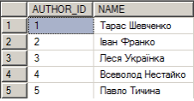

- Book (ID of a book, author’s ID, Name of the book, Type)
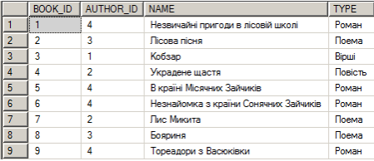

- Indicate SQL command that would return all names of Novels and display their authors.
- Indicate SQL command that would result in a table: list of books types and number of authors writing novels.

3.2 Algorithms

- To determine what will display the following program item and how many times will be executed the loop

(this code has been written in java):

a. int x = 1;
int z;
for(z = 6; z >= 2; z--)
x = x + z;
System.out.println("x = " + x);
System.out.println("z = " + z);

b. int x = 7;
int z;
for(z = 1; z <= 6; z++)

x = x+z;
x = x * 10;
System.out.println("x = " + x);
System.out.println("z = " + z);

c. int x = 2;
int z;
for(z = 6; z <= 2; z++)
x = x + z;
System.out.println("x = " + x);
System.out.println("z = " + z);

d. int x = 0;
int z = 5;
while (z > 1 ){
x = x + 1 / z;
z = z - 1;
}
System.out.println("x = " + x);
System.out.println("z = " + z);

e. int x = 0;
int z = 3;
do {
z = z * 2;
x = x + z;
}
while (z <7);
System.out.println("x = " + x);
System.out.println("z = " + z);

3.3 QC questions

- What is checklist? What is it used for?
- What does the importance and priority of the defect mean?

3.4 Logical tasks

- One family has to cross the river and reach the opposite side going through the suspension bridge at night. Father can do it in 1 minute; mother can do it in 2 minutes, their son – in 5 minutes and his grandmother – only in 10 minutes. They have got one torch. There may be only two people on the bridge at the same time.
How can they cross the bridge in 17 minutes?
Note:
- Two people on the bridge are moving at the speed of the person who is moving more slowly.

- It is forbidden to cross the bridge without a torch, to illuminate the bridge from a distance, to throw the torch over etc.

2. One bacterium was placed into the test tube. It is reproducing so fast that in a second there are received two bacteria from one. In 60 seconds, the test tube was filled with the bacteria. How much time is required to fill the test tube with the bacteria if there are initially placed in the test tube not one but two bacteria?

- There are three lamps in a room with closed door. Outside the room there are three electric switches connected with these lamps. You may manipulate the electric switches, as you like, but after opening the door to the room, you will not be allowed to touch the switches any more. How to determine what lamp is the electric switch connected with?

- Lesia’s father has five daughters: 1) Nana, 2) Nene, 3) Nini, 4) Nono. What is the fifth daughter’s name?

- Which number is hidden behind the question mark?
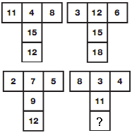

- What time does the last watch show?

4 THE MAIN TASK -FAULTS LOCATION TEST

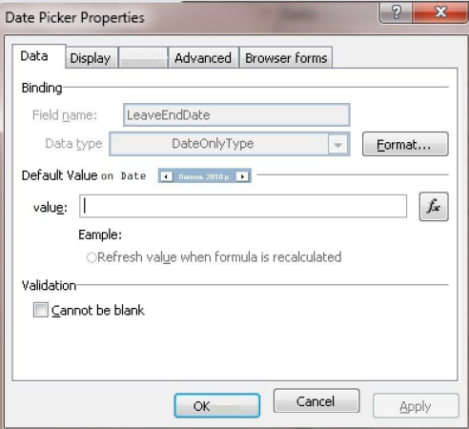

- Describe briefly the purpose of the above mentioned form and list the functions it could have in English (in 3-5 sentences)
- Find and describe all the faults that have been made in the above -mentioned form in English. The description should be structured in the number list.

5 RECOMMENDED ONLINE-TESTS

If you pass this test, it will give you an opportunity to evaluate your level of knowledge:
http://www.geekinterview.com/quiz/Quality-Control-Practice-Test.html

6 REFERENCES

- Lisa Crispin, Janet Gregory Agile Testing: A Practical Guide for Testers and Agile Teams
- Allen G.Taylor SQL For Dummies®, 5th Edition Wiley Publishing, Inc.
- Bruce Eckel Thinking in Java. 4th Edition (chapters: Preface, Introduction, Introduction to Objects, Everything Is an Object, Operators, Controlling Execution, …)

